Name | Singh Suryansh Alok Kumar
UID no. | 2022300119
Experiment No. | Week 9 Day 2

AIM: | Problem Solving Using Object Oriented Programming
Program 1
PROBLEM STATEMENT : | Write a program to calculate the area  of 4 rectangles, 5 squares and 2 circles.  Create an abstract class 'Shape' with three  abstract methods namely 'RectangleArea'  taking two parameters, 'SquareArea' and  'CircleArea' taking one parameter each.  The parameters of 'RectangleArea' are its length and breadth, that of 'SquareArea'  is its side and that of 'CircleArea' is its radius.  Now create another class 'Area' containing all the three methods 'RectangleArea', '  SquareArea' and 'CircleArea' for printing the area of rectangle, square and circle respectively.  Create an object of class 'Area' and call all the three methods.
PROGRAM: | //IMPORTING REQUIRED JAVA CLASSES  import java.lang.Math;  import java.util.Scanner;  //MAIN CLASS  public class Main  {  public static void main(String[] args) {  Scanner sc = new Scanner(System.in);  //MAKING OBJECT ARRAY  Area [] area = new Area[11];  //MAKING OUTPUT ARRAY  double [] opsr = new double [11];  //LOOPING TO TAKE INPUT  for(int i =0 ;i<11;i++){  //FIRST 4 INPUTS FOR RECTANGLE  if(i<4){  System.out.printf("\nEnter the Lenght and breath of the %d Rectangle: ",i+1);  int l=sc.nextInt();  int b=sc.nextInt();  area [i]=new Area();  opsr[i]=area[i].RectangleArea(l,b);  }  //NEXT 5 FOR SQUARE  else if(i<9){  System.out.printf("\nEnter the side of the %d Square: ",i+1-4);  int s=sc.nextInt();  area[i]=new Area();  opsr[i]=area[i].SquareArea(s);  }  //NEXT 2 FOR CIRCLE  else{  System.out.printf("\nEnter the radius of the %d Circle: ",i+1-9);  int r=sc.nextInt();  area [i]=new Area();  opsr[i]=area[i].CircleArea(r);  }  }  System.out.printf("\n\n");  for(int i =0 ;i<11;i++){  //OUTPUTTING IN THE SAME ORDER AS INPUT  if(i<4){  System.out.printf("The area of the %d Rectangle is: %.2f\n",i+1,opsr[i]);  }  else if(i<9){  System.out.printf("The Area of the %d Square: %.2f\n",i+1,opsr[i]);  }  else{  System.out.printf("The area of the %d Circle: %.2f\n",i+1,opsr[i]);  }  }  }  }  //CREATING ABSTRACT CLASS  abstract class Shape{  abstract int RectangleArea(int l,int b);  abstract int SquareArea(int s);  abstract double CircleArea(int r);  }  //CHILD CLASS THAT EXTENDS ABSTRACT CLASS  class Area extends Shape{  //RETURNING THE VALUE AS NEEDED  public int RectangleArea(int l, int b){  return l*b;  }  public int SquareArea(int s){  return s*s;  }  public double CircleArea(int r){  return Math.PI*r*r;  }  }
RESULT:
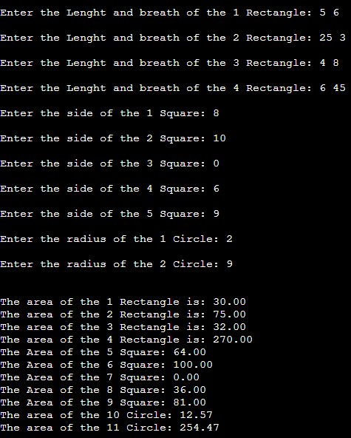
THEORY: | Abstract classes in Java serve as blueprints for other classes. They cannot be instantiated directly, but they can be subclassed to create objects. Abstract classes can have both abstract and concrete methods. Abstract methods are declared without an implementation, while concrete methods have a defined implementation.  Abstract methods are used to enforce specific behavior in the subclasses. Any class that extends an abstract class must provide an implementation for all its abstract methods. This helps in achieving abstraction and polymorphism in Java.  Here's an example of an abstract class with an abstract method and a concrete method:  java  abstract class Shape {  abstract void draw(); // Abstract method  void displayInfo() { // Concrete method  System.out.println("This is a shape.");  }  }  In the above example, the `Shape` class has an abstract method `draw()` and a concrete method `displayInfo()`. Any class that extends `Shape` must provide an implementation for the `draw()` method, but they can inherit the implementation of `displayInfo()`.  Regarding constructors, abstract classes can have constructors, but they cannot be directly instantiated. Constructors in abstract classes are typically used to initialize the fields of the abstract class when an instance of its subclass is created.  Here's an example illustrating the usage of a constructor in an abstract class:  java  abstract class Vehicle {  private String brand;  public Vehicle(String brand) {  this.brand = brand;  }  abstract void start();  }  class Car extends Vehicle {  public Car(String brand) {  super(brand); // Call to the constructor of the abstract class  }  void start() {  System.out.println("The car starts.");  }  }  In this example, the abstract class `Vehicle` has a constructor that initializes the `brand` field. The `Car` class extends `Vehicle` and calls the constructor of the abstract class using the `super` keyword.  To summarize, abstract classes and methods in Java provide a way to define common behavior and enforce specific implementations in subclasses. While abstract classes cannot be instantiated directly, they can have constructors and concrete methods.

